Sami Maizi Project 1 AI

Supervised by: Dr. Rachidi Tajjeddine

Credits:  
Sebastian Lague

https://www.youtube.com/watch?v=-L-WgKMFuhE&list=PLFt_AvWsXl0cq5Umv3pMC9SPnKjfp9eGW

https://github.com/SebLague/Pathfinding

DFS: red

BFS: light blue (I had to remove the other ones since they overlap)

UCS: yellow

A* with Manhattan path heuristic: black

A* with Euclidian path heuristic: dark blue

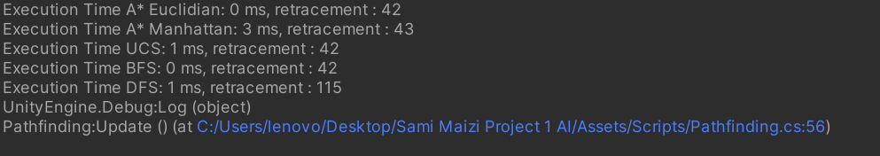  
A* Euclidian Heuristic and BFS are head to head according to the data collected  
Followed by UCS then DFS (with a longer path)

Finally A* Manhattan took longer with one less step then the Euclidian, which stresses the importance of choosing a good Heuristic function